**7R**

**Unit 12**

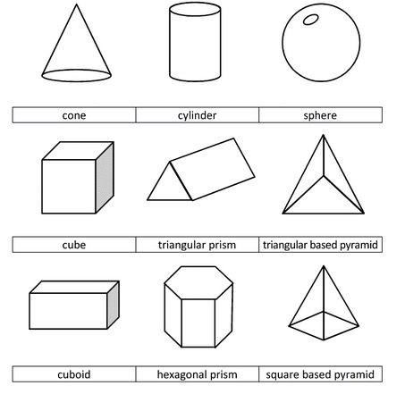**3-D Figures**

NAME _________________________

Period_____________

Teacher_____________

**Unit 11 Lesson 1 – Nets**

**Objective: Today you will learn how to identify parts of and nets of three-dimensional figures**

**Prism - _________________________________________________________________________**

**Pyramid - _______________________________________________________________________**

1. Look at the 3-D shapes below. Write the name of each one and then list what 2D shapes you would need to make each one. Ex) A Rectangular Prism needs 4 rectangles and 2 squares.

f

e

d

c

b

a

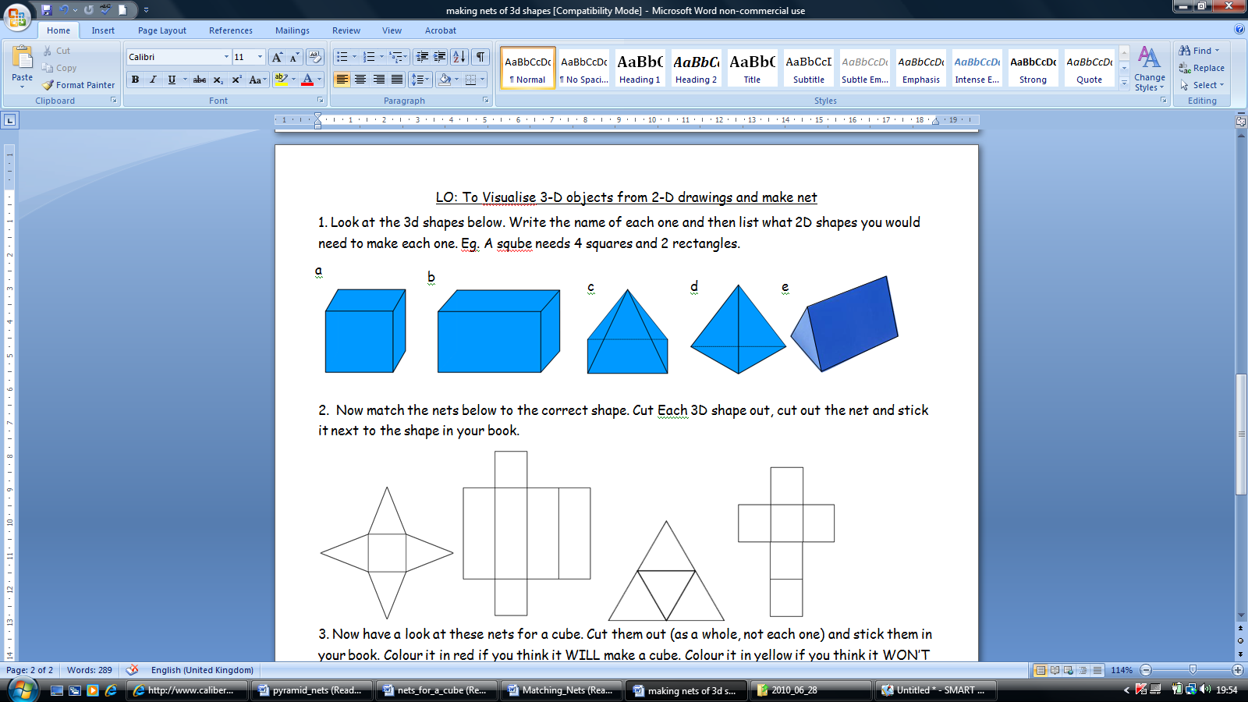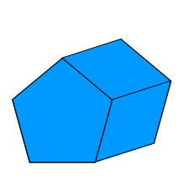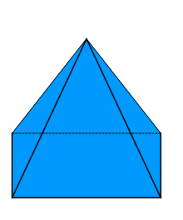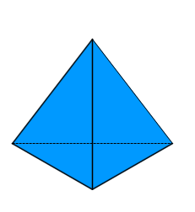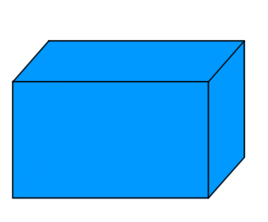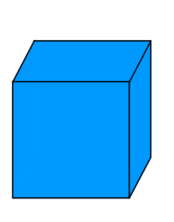

2. Now match the correct net to the correct 3-D figure.

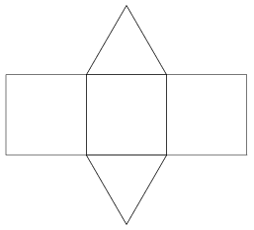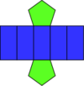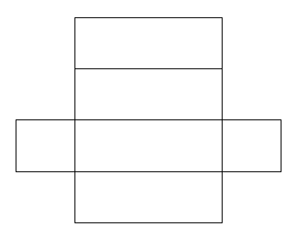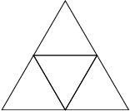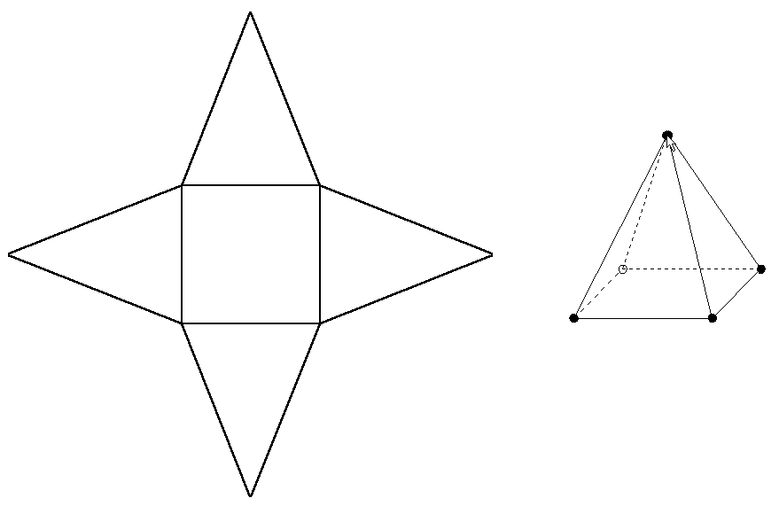1._______ 2._______ 3._____ 4. _______ 5.______ 6.______

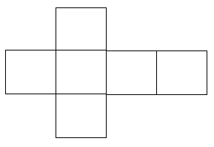

______________________________________________________________________________________________

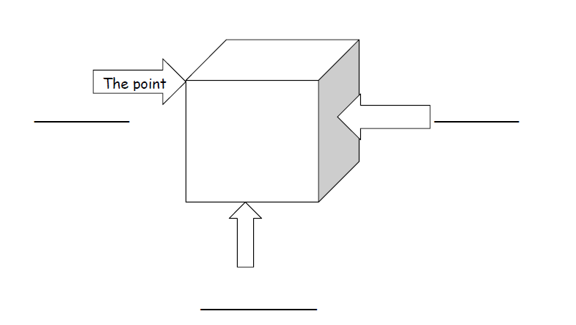

SHADE THE BASE OF EACH 3-D FIGURE!

|  |  |  |  |  |  |
| --- | --- | --- | --- | --- | --- |
| **Solid** | **Number of Face(s)** | **Shape(s) of Face(s)** | **Number of Vertices** | **Number of Edges** | **Prism or Pyramid?** |
| 1. |  |  |  |  |  |
| 2. |  |  |  |  |  |
| 3. |  |  |  |  |  |
| 4. |  |  |  |  |  |
| 5. |  |  |  |  |  |
| 6. |  |  |  |  |  |
| 7. |  |  |  |  |  |

**Unit 12 Lesson 1 - Homework**

**WHAT AM I?**

1. I have 5 faces and 8 edges. My base is a square.

2. I have 4 faces which all triangles.

3. I have 9 edges. My faces are rectangles and my bases are triangles

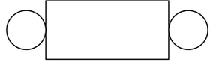

4. This is a net of me….

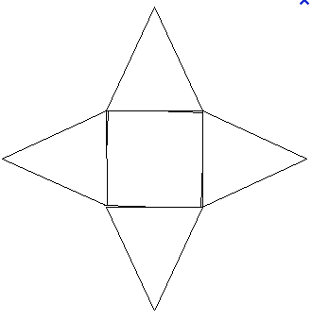

5. This is a net of me….

6. Label each figure as 2-D or 3-D. Explain why your answer is correct. Be sure to include information you learned today in your explanation.

7. Identify the following solid figures.

8. Compare these two figures using their attributes. Before you write, think about the faces, edges, and vertices of both shapes.

**Unit 12 Lesson 2 – Plane Sections (Slicing)**

Objective**: Today you will learn how to describe the cross-sections of three-dimensional figures by slicing at different angles.**

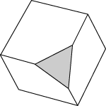Point Line Plane Solid

Vertical ______________________ Horizontal ________________________

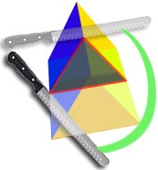**Cross Section** – A cross section is the face you get when you make a slice through a solid.

The **cross section** of this object is a triangle.

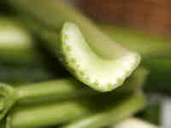It is like a view into the inside of something made by cutting through it.

This is a cross-section of a piece of celery!

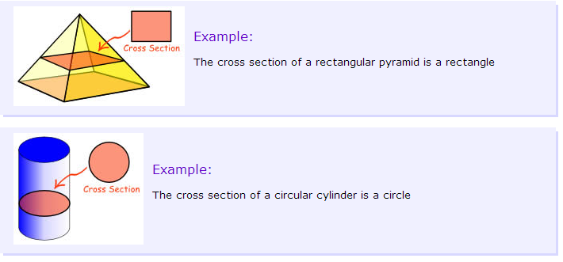

**NOTE:**

**Don’t draw the rest of the object, Just the shape made when you cut through!**

**Is a cross section 2-D or 3-D?**

**Identifying Cross-Sections:**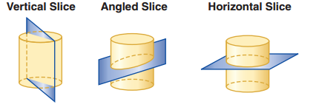

Shape of cross section: _______________ ________________ __________________

**Draw the cross section with the given slice.**

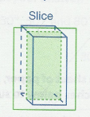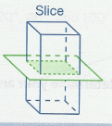**a) Cross section: b) Cross section:**

Draw:

Name:__________________

Draw:

Name:__________________

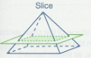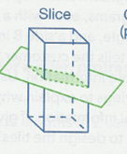**c) Cross section: d) Cross section:**

Draw:

Name:__________________

Draw:

Name:__________________

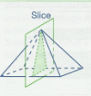

**e) Cross section:**

Draw:

Name:__________________

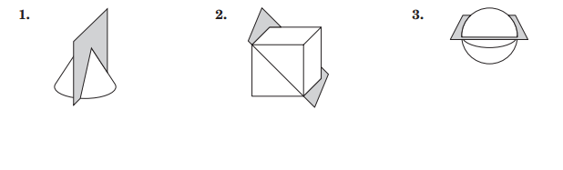**Draw and name the shape resulting from each cross-section.**

**Match the cross-sections of the cube.**

**4. Triangle (not equilateral) 5. Trapezoid 6. Equilateral Triangle 7. Square**

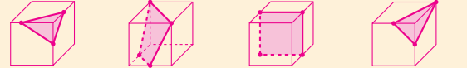 **a. b. c. d.**

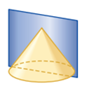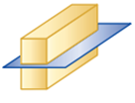**Draw and name the shape resulting from each cross-section.**

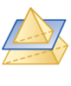

**8. 9. 10.**

Draw:

Name:__________________

Draw:

Name:__________________

Draw:

Name:__________________

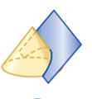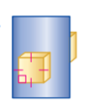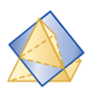

**11. 12. 13.**

Draw:

Name:__________________

Draw:

Name:__________________

Draw:

Name:__________________

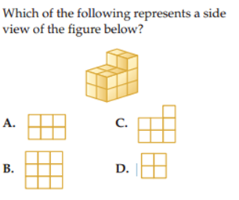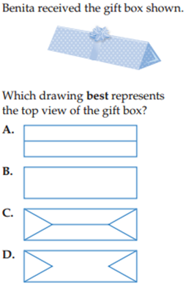

**14. 15.**

**Unit 12 Lesson 2 – HOMEWORK**

1. A carpenter purchased a section of a tree trunk. He wants to cut the trunk into a circle, an oval, and a rectangle. How could he cut the tree trunk to get each shape?

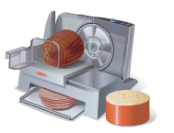

2. A slicer is used to cute whole pieces of meat and cheese for sandwiches. Suppose a customer wants slices of cheese for sandwiches that are round and slices that are rectangular. How can the cheese be placed on the slicer to get each shape?

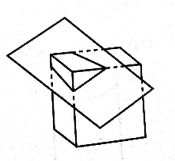

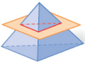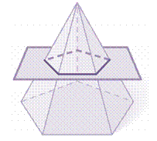Describe the cross section.

3. 4. 5.

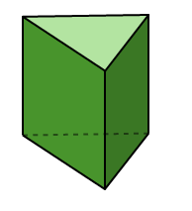

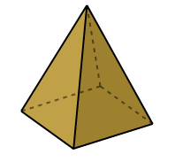6. 7. 8. Which of these is a pyramid?

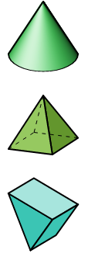

Name ________________

Vertices______________

Edges_________________

Shape of Faces __________

Shape of Base ___________

Name ________________

Vertices______________

Edges_________________

Shape of Faces __________

Shape of Base ___________

REVIEW

9. The ratio of apples to oranges is 2:3. If there are 60 pieces of fruit in the basket, how many oranges are there?



10. What is the percent of of the following shapes are prisms?

**Unit 12 Lesson 3 – Compare Area, Surface Area, Volume, and Perimeter**

**Objective : Today we will learn to determine whether to find area, surface area, or volume in a given situation and find area and perimeter.**

**Perimeter is the distance around a figure.**

**Volume is the number of cubic units needed to fill the space inside a 3D figure.**

**Surface Area is the sum of the areas of the faces of a 3D solid.**

**Area is the amount of space inside a 2D figure.**

**Determine if you would need to find the area, perimeter, surface area, or volume.**

|  |  |  |
| --- | --- | --- |
| 1) How many square inches is this pentagon? | 2) How big is one sheet of loose-leaf paper? | 3) Which is larger California or Michigan? |
| 4) How much cardboard is used to make a box? | 5) How many square feet of fabric were needed to create the tent? | 6) Which gift requires more wrapping paper? |
| 7) How much paint is needed to paint lines around the soccer field? | C:\Users\Stacy\AppData\Local\Microsoft\Windows\Temporary Internet Files\Content.IE5\X1ZILAGD\MC900410689[1].wmf8) How many people can you line the street for a parade? | C:\Users\Stacy\AppData\Local\Microsoft\Windows\Temporary Internet Files\Content.IE5\N7AIDL2C\MP900401415[1].jpgC:\Users\Stacy\AppData\Local\Microsoft\Windows\Temporary Internet Files\Content.IE5\QX0O0R2D\MC900339080[1].wmf9) Whose yard has more fencing? |
| 10) How much soda will fit into this two-liter bottle? | 11) How much orange juice will the carton hold? | 12) Which container will hold more popcorn? |

**Calculate the area and perimeter of the following 2D figures.**

|  |  |  |
| --- | --- | --- |
| **Figure** | **Area** | **Perimeter** |
| (a) |  |  |
| (b) |  |  |
|  |  |  |
| (d) |  |  |
| (e)  9 cm |  |  |

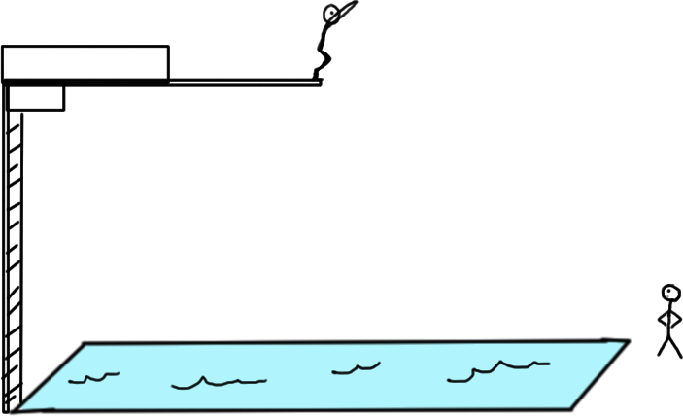CLOSURE – Think of a situation that you would need to find the area, perimeter, surface area, and volume of the swimming pool.

**Unit 12 Lesson 3 - HOMEWORK**

Dana is renovating her house. Decide if each situation requires her to measure area, surface area, perimeter or volume.

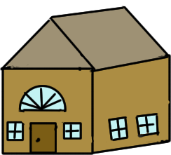1) She wants to paint all the bedroom walls.

2) She needs to buy a new door and needs to know what size to purchase.

3) How much water will fill the pool in the yard.

4) How much fence she needs to enclose the pool.

5) Celia wants to know if the 25 square inches of wrapping paper she has will be enough to cover her mom’s birthday gift. Does she need to find area, surface area, or volume?

6) Darius want to know which bottle will hold more lemonade. Does he need to find area, surface area, or volume?

**Find the area and perimeter of each figure.**

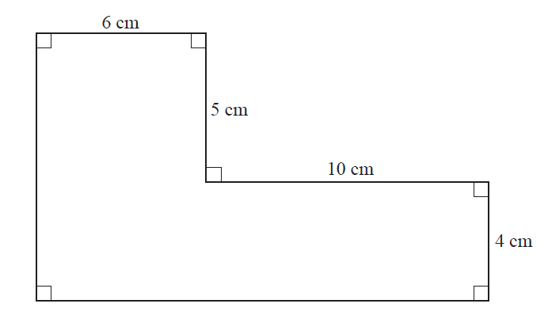**7) 8)**

14.14 cm.

10 cm.

10 cm.

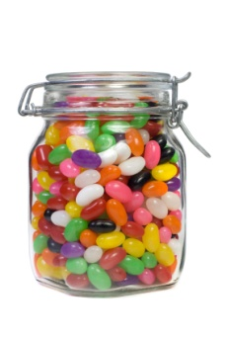**Unit 12 Lesson 3 – Volume**

**Cube, Rectangular Pyramid, Triangular Prism**

**Objective: Today you will discover how to find volume of prisms**

**DO NOW –** How can you estimate how many jellybeans are in the jar?

**Volume –** The measure of space a three-dimensional figure occupies.

**Discover the formula:**

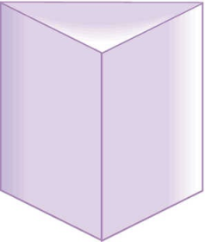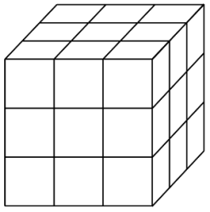Imagine filling each figure with cubes or liquid. As you are filling the figure you will first cover the base of the figure. Then you will continue filling it to the top.

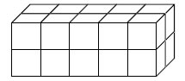

After discussing **how to find** the volume with your group, **find the volumes** of the figures below.

5 in.

5 in.

5 in.

1)

Base

5 in.

5 in.

4.2 in.

4.2 in.

4.2 in.

9 in.

9 in.

9 in.

2) 3)

4)

5 in.

7 in.

6 in.

Base

7 in.

5 in.

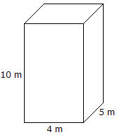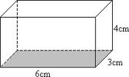5) 6)

7)

3 in.

4 in.

6 in.

3 in.

4 in.

Base

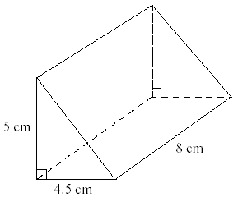

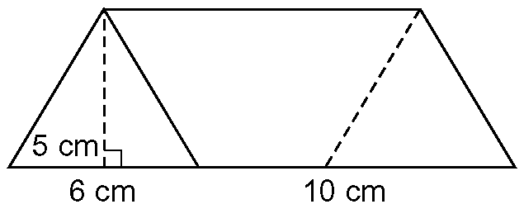

8) 9)

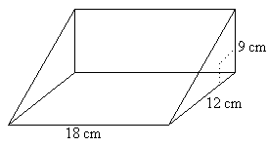

**WORKING BACKWARDS: FIND THE MISSING DIMENSIONS USING THE GIVEN INFORMATION.**

x

V = BH

10) 11)

Volume = 8 m3  12) Volume = 972 cm3

Length = _______ Volume = 504 in3 x = _________

Width = _______ Length = 7 in.

Height = ______ Width = 8 in.

Height = ______

**Unit 12 Lesson 3 – HOMEWORK**

**Find the missing dimension of each prism.**

7 in.

x

9 in.

1. 2.

5.1 in.

7.2 in.

x

Volume = 165.24 in3 Volume = 165.24 in3

2 in.

2 in.

2 in.

3. Suppose the dimensions of the prism are doubled. How does the volume change?

8 in.

4. The prism shown has a base of a trapezoid. Using your knowledge of volume of prisms to find the volume of the prism.

7 in.

5 in.

5 in.

4 in.

Review.

5. 3x + x + 8 = 144 6. -4(x + 3) = 20

7. Factor 9x + 81 8. Find the scale factor.

30 in.

25 in.

6 in.

5 in.

9. Solve: 5 – (2x + 12) = 21 10. Simplify: 4x + 2x – 2y – y

Factor your answer_____________

**Unit 12 Lesson 4 – Surface Area**

**Cube and Rectangular Prism**

**Objective: Today you will discover how to find the surface area of prisms.**

**Discover**

**Problem to think about: Jim and Kim want to wrap two presents. One is a cube and the other a rectangular prism.**

**How can they determine the amount of wrapping paper they will need?**

6 in.

5 in.

16 in.

12 in.

12 in.

12 in.

**Practice**

**Find the surface area of each figure.**

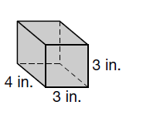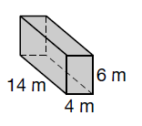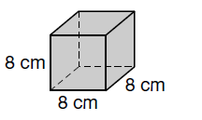1. 2. 3.

**Compare**

4. Bob wants to display some of his photographs. Which has more surface area, a 4 inch by inch by 4 inch photo cube or

a 3 inch by 4 inch by 5 inch prism?

**Test Practice**

5. A box is 6 inch by 9 inch by 2 inch. How many square inches of gift wrap will it take to wrap the box?

a) 168 in2 b) 84 in2 c)186 in2 d) 334 in2

**Challenge**

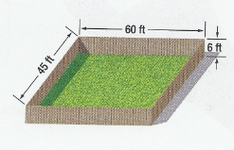6. If one gallon of paint covers 350 square feet, will 8 gallons of paint be enough to paint the **inside and outside** of the fence shown once? Explain.

**Unit 12 Lesson 4 – HOMEWORK**

1. The __________________________ of a three-dimensional figure is the measure of the space it occupies.

2. The sum of all the areas of all the faces of a three-dimensional figure is the ____________________________.

|  |  |  |
| --- | --- | --- |
| FIGURE | Surface Area | Volume |
| 3.  10 in. |  |  |
| 4.  8 in.  7 in.  11 in. |  |  |
|  | 96 in2 | ?????? |

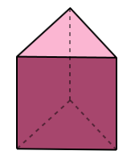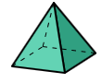5. Draw a net for each figure. A) b)

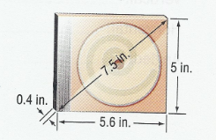6. To the nearest tenth, find the approximate amount of plastic covering wrapper

needed to completely cover the c.d. case.

**Unit 12 Lesson 5 – Surface Area**

**Triangular Prism**

**Objective- Today you will discover how to find the surface area of triangular prisms**

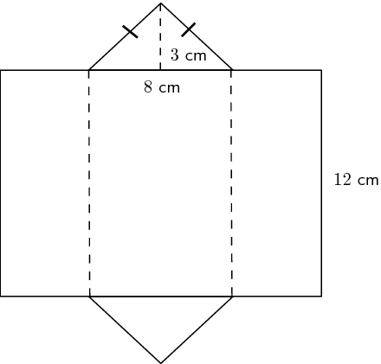

6 cm

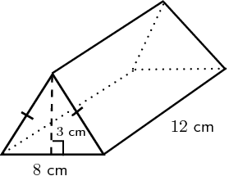

6 cm

side

side

Bottom

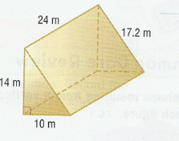**Practice**

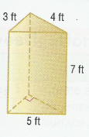1. 2.

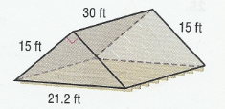

3. The attic shown is a triangular prism. Insulation will be placed inside all

walls, not including the floor. Find the surface area that will be covered with insulation.

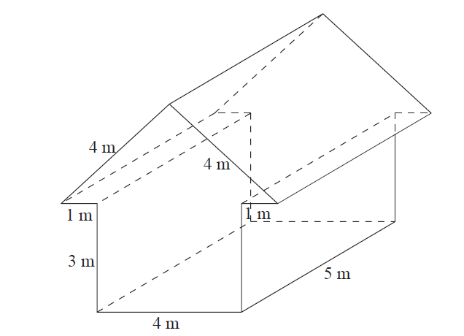

4. Find the surface area of the house. Should we include the ground? yes or no

**Unit 12 Lesson 5 – HOMEWORK**

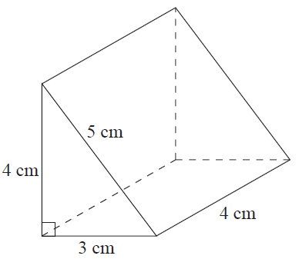

1. a) Draw a net for the triangular prism and label the dimensions.

b) Find the surface area.

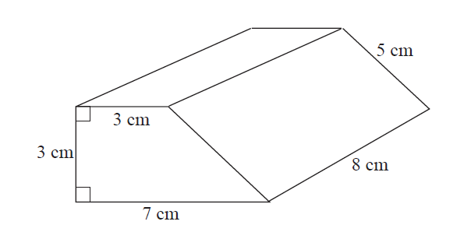2. Find the volume and surface area of the figure.

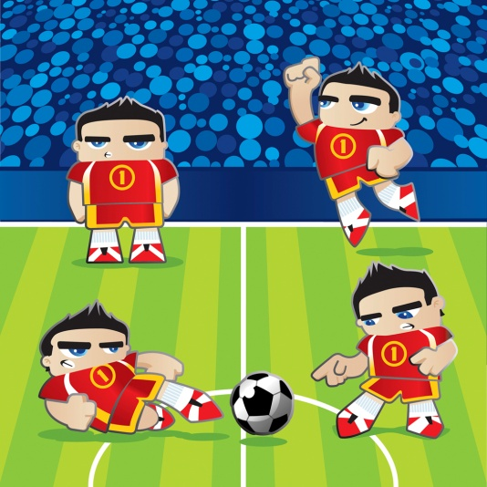

3) Find the perimeter and area of the soccer field in terms of x.

20yd

Part B: If the area of the field is 900yd2 . What is the missing dimension of

the field?

(*x* + 15) yd.

**Unit 12 Lesson 6 – Application**

**Objective: Today you will apply surface area and volume to real-world situations.**

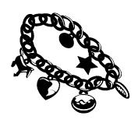1) You are the owner of a prestigious jewelry store that sells popular bracelets. They are packaged in boxes that measure 8.3 cm. by 11 cm. by 2 ½ cm.

**Part I**

a) Sketch a drawing of the box and label its dimensions.

b) Find the volume of the box. Show all your work.

**Part II** – Suppose the company that makes your boxes is out of the ones that you usually purchase. They have offered to send you another size box for the same cost. You choose the box with the most volume. The choices are as follows:

**Choice 1 – 9.3 cm by 11 cm by 2 ½ cm**

**Choice 2 – 8.3 cm by 12 cm by 2 ½ cm**

**Choice 3 – 8.3 cm. by 11 cm. by 3 ½ cm**

c) Find the volume for all three choices. Which box should you choose?

d) What is the difference of the volume of the original box and the volume of the new box?

e) What is the percent of increase in volume for the new box?

**Part III-**Some of your customers frequently like to have their bracelets gift wrapped. To determine the price for wrapping the new boxes, you wish to compare the surface area of the original box with the surface area of the new box.

f) Find the surface area for each box.

g) If you charge $2.00 to gift wrap the original box, how much should you charge to gift wrap the new box? Justify your answer.

2) Jennie purchased a box of crackers from the deli. The box is in the shape of a triangular prism (see diagram).

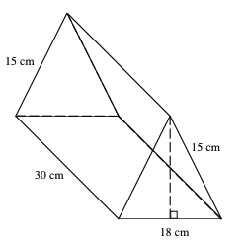

**Part I**

If the volume of the box is 3,240 cubic centimeters, what is the height of the triangular face of the box?

*Show all work*

**Part II**

How much packaging material was used to construct the cracker box?

*Show all work*

**Part III**

**The crackers cost $0.43 per square cm. How much will it cost to fill the box of crackers?**

**Unit 12 Lesson 6 – HOMEWORK**

1) The house to the right is in need of a new roof.



20 feet

60 feet

7 feet

a) How many square feet of shingles must be purchased?

b) Roofing is measured in “squares”. A square is equal to 100 square feet of roofing. How many squares must be purchased?

c) A square costs $65. How much will the new roofing cost?

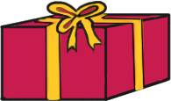2) A website sells value rolls of wrapping paper and advertises that, “the most popular size is 25 inches by 408 inches, which can wrap approximately 200 gifts”.

a) How many square feet of wrapping paper are on one roll?

b) According to this website, what is the surface area of an average gift?

c) If the roll costs $40, about how much does it cost to wrap one gift?

3) Cereal boxes have the dimensions indicated in the illustration. The cereal box factory is about to close for the weekend, and there are just 1,000 in2 of cardboard left. How many more cereal boxes can be produced at the factory with the remaining cardboard?

